**Analysing Ad Budgets for different media channels**

DESCRIPTION

**Problem:**

The given dataset contains ad budgets for different media channels and the corresponding ad sales of XYZ firm. Evaluate the dataset to:

* Find the features or media channels used by the firm
* Create a model  to predict the sales outcome
* Split as training and testing datasets for the model
* Calculate the Mean Square Error (MSE)

* Find the features or media channels used by the firm

The correlation matrix suggests that there is a strong correlation between Sales and TV Ad Budget. The values is continuous. So here we use Multiple linear Regression to predict the Sales based on TV , Radio and Newspaper Ad Budgets.

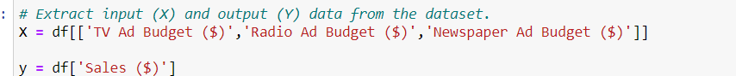

Since we are using Multiple Linear Regression, X will be the independent variables - TV , Radio and Newspaper Ad Budgets. Y will be the dependent or response variable – Sales.

Data is randomly split into train and test datas. Train data is 80% of the total data which is 160 records and test data is 40 records.

Here we have the intercept and coefficients needed for the linear regression equation y = mx + c where m is coefficient and c is y-intercept.

Above, we have the prediction sales values.

The root mean square error for the test data is 1.316.

The R-Square value is 0.89. Any value closer to 1 suggests a good model. Here our R-square value of 0.89 suggests that our model is close to accurate in predicting the sales. You can see from the below chart that the model does a nice job of predicting values.

